Unveiling Research Synergies in the Danube Region: Exploring Potential Research Collaboration in the Context of Smart Specialisation

Author:
Lazar Živković

Editors:
Viktor Nedović
Dijana Štrbac

TABLE OF CONTENTS
1. Introduction 3
1.1. Background and Objectives of the Study 3
2. Smart Specialisation Strategies in the Danube Region 4
2.1. Overview of the Smart Specialisation Framework 4
2.2. Relevance of S3 to the Danube Region 4
2.3. The Importance of Research Cooperation 5
3. Identification of Key Research Domains in the Danube Region Based on S3 Priority Areas 6
3.1. The most common S3 priority areas in the Danube region 6
4. Unveiling collaboration patterns and networks in the Danube region countries 8
4.1. Research Participation of the Danube Region countries in Horizon Europe Projects 8
4.2. Key research sub-fields in the Danube Region: focus on top S3 priorities 9
4.3. Collaboration networks in the Danube Region: focus on main S3 areas 12
4.3.1. Research cooperation in Agri-Food, Bioeconomy & Biotechnology 14
4.3.2. Research cooperation in ICT and Digitalisation 18
4.3.3. Research cooperation in Climate and Energy area 22
5. Key Findings and Policy Recommendations 27
5.1. Summary of Key Findings 27
5.2. Future Directions for Research Collaboration in the Danube Region 28
References 30

Introduction

Background and Objectives of the Study
The Danube Region offers significant opportunities for fostering research partnerships that can drive regional integration and economic growth. By leveraging the Smart Specialisation Strategies (S3) framework, countries in this region can focus on their unique assets to address shared challenges and promote sustainable innovation. This region, characterized by cultural diversity and economic variability, is a fertile ground for cross-border research efforts. Ongoing initiatives, including EU-supported funding programs and interregional projects, highlight the growing commitment to collaboration and resource sharing to achieve technological and scientific breakthroughs (European Commission, 2020; Foray, 2014).
Efforts to implement S3 are not limited to EU Member States. Non-EU countries in the Danube Region have also embraced this approach with guidance from the European Commission’s Joint Research Centre. By aligning innovation strategies with the S3 framework, these countries aim to accelerate their transition to knowledge-driven economies and strengthen their integration into European research networks (Radovanovic & Benner 2019). This coordinated approach fosters targeted investment in high-impact areas while addressing structural challenges like productivity gaps and fragmented standards (Barca, 2009; McCann & Ortega-Argilés, 2013).
As a cornerstone of European innovation policy, S3 promotes bottom-up strategies that empower regions to identify their competitive advantages and prioritize their investments accordingly. For the Danube Region, this framework is especially valuable in addressing disparities between advanced and emerging economies, as well as between EU and non-EU countries. Collaborative innovation can bridge these divides, enabling the region to tackle socio-economic challenges such as brain drain and unequal access to funding.
Building on successful models from other regions, the Danube countries have the potential to amplify their strengths through coordinated actions and strategic partnerships. By aligning their efforts within the S3 framework, stakeholders can establish a cohesive ecosystem that supports sustainable development and contributes to broader European objectives. This study, based on an analysis of Horizon Europe projects from 2021 to 2024, explores the current state of research collaboration in the Danube Region, identifies key research domains, and provides actionable recommendations for fostering stronger interregional synergies. Specifically, it addresses the following key questions:
- What are the most common priority research areas identified in the Smart Specialisation Strategies of Danube Region countries? By examining these areas, the study aims to highlight thematic strengths and identify opportunities for alignment across borders.
- How are the research networks structured in the region, particularly in terms of connectivity, centrality, and collaboration patterns? Social network analysis is used to uncover the dynamics of these networks and to determine the role of key institutions.
- What are the emerging subfields in the most common S3 priority areas? The study explores the specific sub-themes driving innovation in these domains.
- How can the region foster greater synergy and inclusivity in research collaboration? Based on the findings, the study offers actionable recommendations to address disparities and strengthen the collective research impact of the region.

Smart Specialisation Strategies in the Danube Region

2.1. Overview of the Smart Specialisation Framework
Smart Specialisation Strategies were introduced by the European Union as a transformative framework to enhance regional innovation and foster economic growth by focusing on areas of comparative advantage. This policy concept encourages regions to identify and invest in sectors with high innovation potential, leveraging their unique strengths and resources. It employs a bottom-up approach, emphasizing active stakeholder engagement and evidence-based decision-making to align investments with regional priorities (Foray et al., 2009; Foray, 2014; European Commission, 2012).
The S3 framework prioritizes innovation by enabling regions to define their unique strengths, address societal challenges, and align efforts with market demands. This approach is particularly relevant for tackling critical global issues such as digital transformation, climate change, and demographic shifts. By fostering collaboration among public, private, and academic sectors, S3 creates a dynamic environment that drives impactful innovation outcomes (McCann & Ortega-Argilés, 2013).

2.2. Relevance of S3 to the Danube Region
The Danube Region, with its blend of advanced economies and emerging markets, represents a unique setting for implementing the S3 framework. Its cultural diversity, economic disparities, and varying levels of industrial and research capacities necessitate tailored policy approaches that bridge gaps and leverage shared opportunities. The S3 framework provides a structured methodology for addressing these complexities by aligning national and regional innovation systems, fostering cross-border collaboration, and enhancing research and development capacities across the region (European Commission, 2020). Moreover, S3 plays a crucial role in supporting EU policy alignment, ensuring that innovation strategies in the Danube Region are in line with broader European objectives, such as the European Green Deal and Digital Strategy.
One of the key strengths of S3 is its flexibility in accommodating the diverse socio-economic landscape. By identifying regional strengths and niche areas of excellence, S3 enables countries to concentrate on sectors where they can achieve competitive advantages. The framework encourages bottom-up governance, where regional stakeholders (universities, research institutions, businesses, and policymakers) collaborate in shaping research and innovation priorities that reflect both local needs and global trends. By fostering structured cross-border partnerships, aligning research priorities, and creating interconnected research networks, S3 strengthens the European Research Area (ERA). Additionally, for non-EU countries in the region, S3 serves as an important instrument in the EU accession process, helping them align their research and innovation policies with EU standards, thus facilitating smoother integration into European funding programmes and collaborative initiatives.
As a result, countries in the Danube Region benefit from joint initiatives, shared research infrastructures, and collaborative funding opportunities, reducing fragmentation in national innovation ecosystems. Furthermore, S3 is instrumental in promoting the green and digital transition by encouraging investments in sustainable technologies, digital transformation, and climate-friendly innovations. By integrating sustainability and digitalization into regional innovation strategies, the S3 helps accelerate the transition toward a more resilient and future-oriented economy.

2.3. The Importance of Research Cooperation
Research cooperation is the foundation of scientific and technological advancement, facilitating the sharing of knowledge, expertise, and resources among diverse stakeholders. Collaborative research accelerates innovation, strengthens global competitiveness, and enables regions to address complex challenges that transcend national borders, such as climate change and public health crises (OECD, 2018). The benefits of research cooperation extend beyond individual projects. Collaborative efforts enhance institutional capacity, foster long-term innovation, and promote the development of research infrastructure. Research networks also facilitate knowledge exchange, leading to broader societal impacts and fostering a culture of innovation (Katz & Martin, 1997). Engaging in international research collaboration yields outcomes that exceed those of isolated local teams, underscoring the significance of cross-border research efforts (Auanassova, 2023). By combining expertise and resources, nations can enhance their scientific contributions and enrich the global knowledge landscape.
In the Danube Region, research cooperation plays a vital role in addressing regional disparities and fostering integration. Shared challenges, such as fragmented innovation systems and brain drain, require collaborative solutions that pool resources and expertise. By strengthening research networks, countries in the region can build robust innovation ecosystems and enhance their global competitiveness. Programs such as Horizon Europe, the Interreg Danube Region Programme, and other initiatives supported by the European Commission demonstrate the transformative potential of research cooperation.
The Danube Region’s diverse economic and cultural landscape presents unique opportunities for fostering partnerships. Research cooperation not only enhances competitiveness but also builds trust and strengthens relationships among participating countries. As networks expand, they contribute to the region’s capacity to address shared challenges, such as climate adaptation, digital transformation, and energy transition. The successful implementation of S3 in the Danube Region depends heavily on robust research cooperation. By fostering collaboration, S3 helps regions identify their strengths, align investments with regional capabilities, and prioritize high-impact research areas. Research cooperation also ensures that innovation efforts are inclusive, bridging gaps between advanced and emerging economies and promoting equitable development. For example, collaborative research in ICT has demonstrated how shared resources and expertise can drive advancements in artificial intelligence and digital transformation. These synergies exemplify how research cooperation strengthens the effectiveness of S3, enabling the Danube Region to contribute to broader European and global innovation goals. Evidence from the Western Balkans underscores the role of research cooperation in ICT and digitalisation (Fabbri et al., 2025). The study also highlights that digitalisation and sustainability efforts are increasingly being driven by cross-border collaborations. However, financial constraints and limited awareness remain key barriers to expanding cooperation​. These insights reinforce the need for strategic investments in research networks and public-private partnerships to accelerate the digital and green transformation.
Empirical evidence also suggests that the implementation of S3 fosters transnational research collaborations, particularly among regions that exhibit complementary strengths, thereby stimulating both innovation and economic growth (Radosevic, 2018; Woolford et al., 2021). By engaging in joint research and development activities, countries can work together to tackle regional challenges such as environmental sustainability, public health concerns, and economic inequalities, ensuring that solutions are both targeted and contextually relevant. Furthermore, regional cooperation strengthens educational and research networks, enhancing local capacities and workforce development while simultaneously facilitating the exchange of knowledge, best practices, and innovative technologies that are adapted to specific regional needs.

Identification of Key Research Domains in the Danube Region Based on S3 Priority Areas

3.1. The most common S3 priority areas in the Danube region
To identify common research priorities across the Danube region, a systematic and structured approach was applied (Figure 1). This methodology ensured that the analysis captures the diverse innovation ecosystems of the region and reflects their specific strengths and opportunities:
- Compilation of research priorities: Each country’s S3 strategies were reviewed to compile a comprehensive list of priority research areas. These strategies reflect national and regional objectives and provide a detailed overview of the priority areas for innovation and development.
- Frequency analysis: The frequency of each priority area was analysed across the Danube region to assess its importance and relevance. This step highlighted recurring themes and provided insight into areas where cooperation could have the greatest impact.
- Clustering of similar priorities: To identify synergies, similar priority areas were grouped into broader categories. This step helped to harmonise the priorities of countries with overlapping interests while considering regional differences.
- Ranking of common priorities: Priority areas were ranked according to the number of countries emphasising them. This ranking emphasises the most prevalent research areas and provides a roadmap for targeted collaboration and resource allocation.
Figure 1: Step-by-step approach conducted to identify the common S3 priority areas in the Danube Region

The analysis has identified key areas of research and innovation that resonate strongly across the Danube region. These areas underline both regional strengths and global relevance (Table 1).
Table 1: The list of most common S3 priority areas in the Danube region countries
Priority area | Number of occurrences | Description
Agri-Food, Bioeconomy & Biotechnology | 11 | Covers sustainable agriculture, food security, and bioeconomy to support environmental sustainability.
ICT and Digitalisation | 10 | Focuses on digital transformation, Industry 4.0, and ICT-enabled solutions to enhance connectivity, digital skills, and automation.
Climate and Energy | 9 | Emphasizes renewable energy, energy efficiency, and climate resilience to mitigate climate change and transition to greener economies.
Health and Medicine | 8 | Encompasses healthcare technologies and public health to improve medical research and healthcare systems.
Smart Automotive & Mobility | 6 | Focuses on sustainable transport solutions, including electric vehicles and mobility innovations.
Creative Industries | 5 | Highlights innovation in arts, media, and design, fostering economic growth through creative contributions.
Materials | 4 | Includes research in advanced materials to support industrial innovation and sustainable practices.
Mechatronics and Microelectronics | 3 | Focuses on advanced manufacturing technologies, automation, and electronic systems.
Tourism | 3 | Recognizes the cultural and natural heritage of the region, promoting innovation in tourism services.
Manufacturing | 1 | Highlights niche manufacturing sectors with potential for targeted growth and innovation.
Wood | 2 | Emphasizes forestry-related industries, sustainability, and the development of wood-based products.
Source: Author's calculation based on the official S3 documents of the individual countries of the Danube region
Among the identified priority areas in the Danube Region, Agri-Food, Bioeconomy & Biotechnology, ICT and Digitalisation, and Climate and Energy are the three most frequently prioritized and thus underscore their central role in regional innovation agendas. Agri-Food, Bioeconomy & Biotechnology is a cornerstone of the Danube Region’s innovation agenda given its strong agricultural base, the growing importance of sustainable food systems and the potential of biotechnology to add value and promote resilience across the agri-food sector. ICT, with its focus on digital transformation, Industry 4.0 and advanced connectivity, is central to improving the region's technological capabilities and modernizing the economy. This priority area supports the digital economy, promotes automation and is in line with the global shift towards technology-driven development. The area of climate and energy is also of immense importance as the region faces the challenges of climate change and the transition to sustainable energy systems. This area underlines the region's commitment to renewable energy, energy efficiency and climate resilience and positions the Danube region as a leader in the global quest for a greener and more sustainable future.
These shared priorities show that the Danube Region countries have recognized the need to align with European objectives such as the Green Deal, the Farm to Fork Strategy, and the Digital Europe Programme. This alignment not only strengthens their capacity to tackle cross-border challenges, such as climate change and digital transition, but also positions the region as an active contributor to Europe’s broader innovation and sustainability agenda.

Unveiling collaboration patterns and networks in the Danube region countries

Research Participation of the Danube Region countries in Horizon Europe Projects
Participation in Horizon Europe projects is an important indicator of research engagement and innovation capacity. This section assesses the participation of organizations from the region in Horizon Europe Programme, focusing on both absolute participation figures and participation per capita. By considering per capita participation, this analysis ensures fair comparisons between countries with different population sizes and provides a nuanced understanding of research dynamics.
The analysis is based on data downloaded from the CORDIS (Community Research and Development Information Service) platform, which provides comprehensive information on Horizon Europe projects, including participants, funding and geographical distribution. The dataset was filtered to include only projects involving organizations from the countries of the Danube region. For Germany, only the regions of Bavaria and Baden-Württemberg were included, as they belong to the Danube Region.
Table 2 shows the number of participations, the population size and the participation per capita for each country. It highlights both absolute contributions and relative performance and provides deeper insights into research engagement.
Slovenia leads the Danube Region with 509 participations per million inhabitants, a figure that highlights its advanced research ecosystem and strong integration into Horizon Europe programmes. Austria follows with 309 participations per million inhabitants, while Bavaria and Baden-Württemberg, representing Germany within the region, also demonstrate solid performance with 180 participations per million inhabitants.
Croatia, the Czech Republic and Bulgaria have a moderate per capita level of between 88 and 130 participations per million inhabitants. These figures illustrate the steady progress in aligning with Horizon Europe objectives and show that these countries are strengthening their research and innovation frameworks.
Non-EU countries, Bosnia and Herzegovina, Moldova and Montenegro show lower participation rates, both in absolute terms and per capita. These figures underline limited research capacity and difficulties in accessing EU funding. Serbia stands out as the dominant performer in this group, leading both in absolute participation numbers and per capita involvement in Horizon Europe programmes. Ukraine, with its large population, has the lowest per capita participation rate. This reflects the ongoing challenges related to political instability, economic difficulties and the impact of the conflict on the country's research and innovation capacities.
Table 2: Horizon Europe participation by country in the Danube Region (2021-2024)
Country Code | Country | Number of participations | Population (in millions) | Participation per million inhabitants
AT | Austria | 2,789 | 9 | 309.89
BG | Bulgaria | 610 | 6.9 | 88.41
HR | Croatia | 522 | 4 | 130.5
CZ | Czech Republic | 1,369 | 10.7 | 127.94
DE | Germany (Bavaria & Baden-Württemberg) | 4,358 | 24.2 | 180.08
HU | Hungary | 781 | 9.6 | 81.35
RO | Romania | 1,067 | 19.1 | 55.87
SK | Slovakia | 422 | 5.4 | 78.15
SI | Slovenia | 1,069 | 2.1 | 509.05
BA | Bosnia and Herzegovina | 51 | 3.3 | 15.45
MD | Moldova | 66 | 2.6 | 25.38
ME | Montenegro | 32 | 0.6 | 53.33
RS | Serbia | 455 | 6.8 | 66.91
UA | Ukraine | 333 | 41.2 | 8.08
Source: CORDIS and Eurostat database

Key research sub-fields in the Danube Region: focus on top S3 priorities
This section examines the most important areas of research in the three most common sub-fields: Agri- Food, Bioeconomy & Biotechnology, ICT and Digitalisation and Climate and Energy, highlighting their importance and relevance to the regional and global innovation agenda. These three areas have emerged as the most prominent S3 focus areas in the Danube Region and reflect the strategic focus of the region. Understanding the research landscape in these areas provides insights into regional strengths, opportunities for collaboration and potential policy measures to further support innovation.
Research sub-areas in Agri-Food, Bioeconomy & Biotechnology
Horizon Europe project activities in the Danube Region reveal a strong and sustained focus on Agri-Food, Bioeconomy & Biotechnology. This focus shows the region’s commitment to developing knowledge and solutions that make food systems more resilient, resource-efficient, and innovation-ready. This area is important because it combines food production, rural livelihoods and the sustainable use of biological resources with practical objectives such as improving plant and animal health, adding value to biomass, improving the safety and efficiency of supply chains and reducing waste and emissions.
The Danube Region places strong emphasis on understanding and managing natural systems as a foundation for bioeconomy development, with ecosystems emerging as the most common research sub-area among approved projects (Figure 2). Beyond ecosystems, research also extends across key molecular biosciences such as proteins, genetics, and DNA, which provide the scientific base for new breeding methods, diagnostics, and bioprocessing technologies. Fields related to biosecurity and food safety, including virology, bacteriology, and mycology, show the importance of protecting plant, animal, and human health along the food chain. At the same time, areas linked to the blue bioeconomy (marine and freshwater biology) and to sustainable agriculture highlight the region’s potential to diversify biomass sources and connect innovation directly to primary production. Cross-cutting enablers like recycling and synthetic biology reflect the growing shift towards circularity and bio-based innovation. Taken together, this portfolio reveals a comprehensive approach: integrating ecosystem intelligence, molecular science, and circular resource use to deliver practical solutions for food security, health, and sustainability in line with European bioeconomy objectives.
Figure 2: Number of projects per Agri-Food, Bioeconomy & Biotechnology sub-areas with participation of Danube Region countries (Horizon Europe 2021-2024)
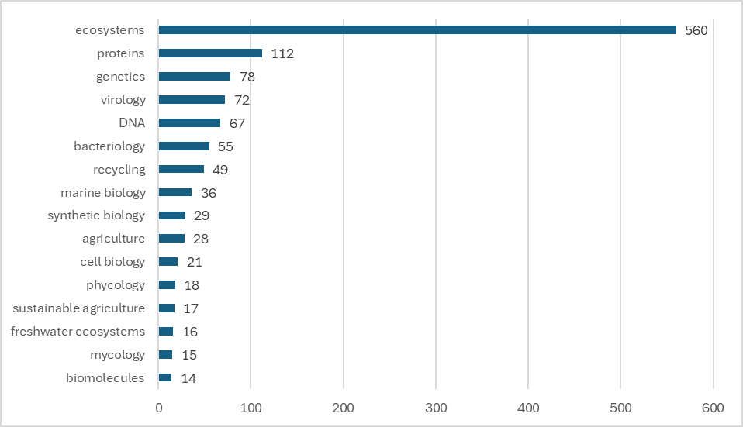
Source: Author’s calculation based on the CORDIS database

Research sub-areas in ICT and Digitalisation
As one of the most prioritised fields, the ICT sector underpins the Danube Region’s transition to a digital economy and supports the emergence of new business models. Project participation data highlight the key ICT and Digitalisation research sub-areas funded under Horizon Europe (Figure 3). Software development dominates with 476 projects, reflecting strong regional expertise in software engineering, application development, and digital innovation. Artificial intelligence follows with 401 projects, confirming the growing role of AI in shaping competitiveness and technological upgrading. The Internet of Things (272 projects) ranks third, underscoring the region’s commitment to advancing connectivity and automation as foundations for smart cities and Industry 4.0.

Figure 3: Number of projects per ICT and Digitalisation sub-areas with participation of Danube Region countries (Horizon Europe 2021-2024)
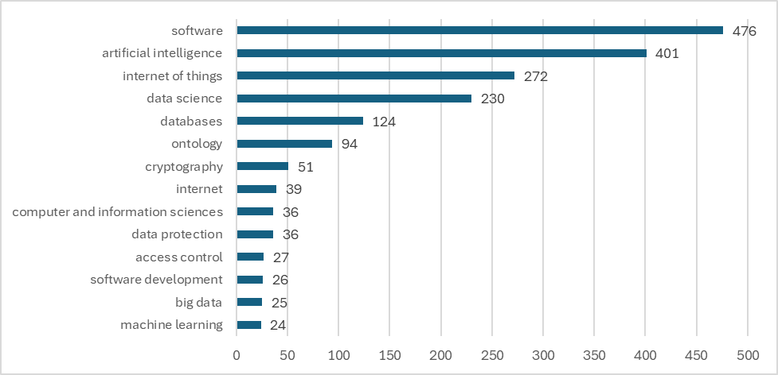
Source: Author’s calculation based on the CORDIS database

Research sub-areas in Climate and Energy
Climate and Energy research is crucial to tackling environmental challenges, promoting sustainability and ensuring energy security in the region. Given the EU’s ambitious climate targets and the increasing urgency of the transition to low-carbon energy sources, research in this area has gained considerable momentum. The most common sub-areas of Horizon Europe projects are shown in Figure 4.
These results reflect the region’s commitment to green innovation and sustainable energy development. The focus on recycling, renewable energy and wastewater management is in line with EU policies on climate resilience and sustainability. The strong focus on renewable energy and circular economy solutions demonstrates the region’s alignment with global sustainability goals. However, further investment is needed to develop energy storage solutions, smart grids and hydrogen technologies to improve the efficiency and scalability of clean energy systems.

Figure 4: Number of projects per Climate and Energy sub-areas with participation of Danube Region countries (Horizon Europe 2021-2024)
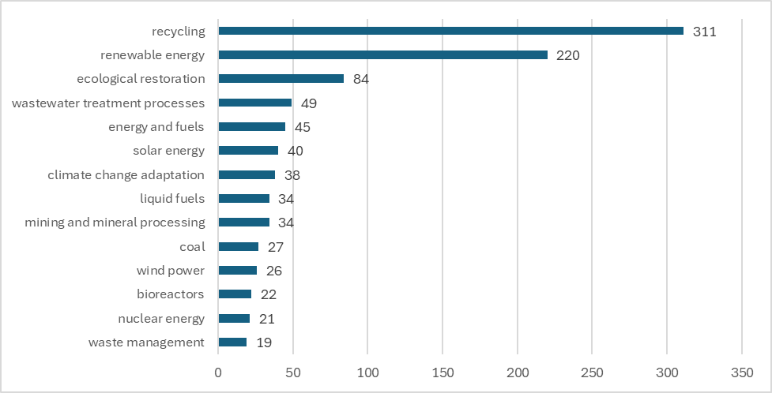
Source: Author’s calculation based on the CORDIS database
Although Agri-Food, Bioeconomy & Biotechnology, ICT, and Climate ana Energy are treated as distinct domains, their interconnections are becoming increasingly evident. Digital tools such as AI and big data are not only transforming energy systems, smart grids, and climate adaptation, but also reshaping agriculture through precision farming, biotechnology applications, and resource-efficient food systems. The convergence of these fields creates opportunities for smarter, more sustainable solutions demonstrating how digitalisation underpins both the green and bioeconomy transitions in the Danube Region.

Collaboration networks in the Danube Region: focus on main S3 areas
Social Network Analysis (SNA) was utilized to map and examine research collaboration networks in the selected priority areas across the Danube Region. SNA is a methodological framework that investigates the relationships and structures within a network by analysing various indicators. This interdisciplinary approach integrates theoretical concepts, models, and practical applications, emphasizing the relational dynamics and the significance of the interactions among the analysed units. The interconnections and defined links between these units are central to the theory of network analysis (Wasserman and Faust, 1994).
For this analysis, the specialized software tool Pajek was employed. Pajek is designed to facilitate the study and visualization of large networks. It allowed for the efficient computation of key network metrics and the creation of visual representations of the network structure, showcasing the connections and central roles of various entities within the network.
The following SNA indicators were used to assess research collaboration networks:
- Degree centralisation of each organisation within the Danube region: This metric evaluates the centrality of the specific organisation by measuring its connectivity within the network. Despite being a straightforward measure, it effectively highlights the prominence or influence of an individual actor within the network. The more connections an actor has, the greater its influence over others. Degree centrality is calculated by dividing the number of connections an actor possesses by the total number of actors in the network, minus one:
$$C_{n1}=\frac{D_{n1}}{G-1}$$
Where:
- D_{n1} – Number of connections of the observed actor in the network
- G – Total number of actors in the network

- Betweenness centralisation of each organisation within the Danube region: This indicator measures the extent to which the specific organisation functions as an intermediary within the network. It reflects the actor’s role in linking others and facilitating the flow of information. Betweenness centrality calculates how frequently an actor lies on the shortest path between two other members of the network. The formula for this indicator is:

$$C_{b}\left(n_{i}\right)=\sum_{j=n=k}{g_{jk}}\left(n_{i}\right)/g_{jk}$$
Where:
- g_{jk} (n_{i}) - The number of shortest paths between actors j and k that include actor i
- g_{jk} - The number of shortest paths between actors j and k

- Closeness centralisation of each organisation within the Danube region: This metric quantifies how central the specific organisation is in terms of its accessibility to all other organisations in the network. It measures how close an actor is to others, with higher values indicating quicker communication capabilities and less reliance on intermediaries. The formula for closeness centrality is:

$$C_{c}n_{i}=\frac{N-1}{\sum_{j=1}^{N}{d(n_{i }{,n}_{j}) }}$$
Where:
- d(n_{i},n_{j}) – the distance function of actor 𝑖 from all other 𝑗 members in the network
- N – the number of actors in the network

Research cooperation in Agri-Food, Bioeconomy & Biotechnology
The Agri-Food, Bioeconomy & Biotechnology collaboration network in the Danube Region shows a robust but dense structure. Figure 5 illustrates this network, which includes only those organizations from the Danube Region that participate in at least three Horizon Europe projects and that have at least one partner from within the region. In the visualization, each node represents an organization, with the node size directly reflecting the number of implemented projects, larger nodes correspond to organizations involved in a higher number of projects. The lines connecting the nodes depict collaboration patterns, where thicker lines indicate stronger cooperation, signifying that the linked organizations have a greater number of joint projects. While a significant number of organizations participate in Horizon Europe projects, the degree of networking is somewhat fragmented, with different clusters forming around a limited number of central institutions. This indicates a moderate level of integration, where collaborations exist but many actors are only connected via a few strong nodes rather than forming a closely connected network.
The cooperation network is dominated by large institutions that act as primary hubs. The Fraunhofer Society (Germany), Technical University of Munich (Germany), and the AIT Austrian Institute of Technology (Austria) stand out for their large node sizes and extensive links, confirming their role as regional leaders in transnational research. Alongside them, the Max Planck Society (Germany) is remarkable as the overall leader in project numbers, though with a less extensive reach across partners. Several other universities and research centres also play key roles in the core of the network: Jožef Stefan Institute (Slovenia), University of Tubingen (Germany), and University of Vienna (Austria).
The geographical structure of the network is shaped by the dominance of Germany and Austria, home to several of the most central institutions. Strong representation is also visible from Slovenia and the Czech Republic, with organisations such as the Jožef Stefan Institute, Masaryk University, and the Czech University of Life Sciences Prague occupying prominent positions. On the other side, institutions from Romania, Bulgaria, Croatia, and Serbia are positioned more towards the periphery, often linked to only one or two central hubs rather than embedded in the core. This illustrates a clear imbalance: while Western Balkan and Eastern Danube actors do participate, their level of integration into collaboration networks remains limited compared to their German and Austrian counterparts.

Figure 5: Agri-Food, Bioeconomy & Biotechnology Cooperation Network in the Danube Region (Horizon Europe)
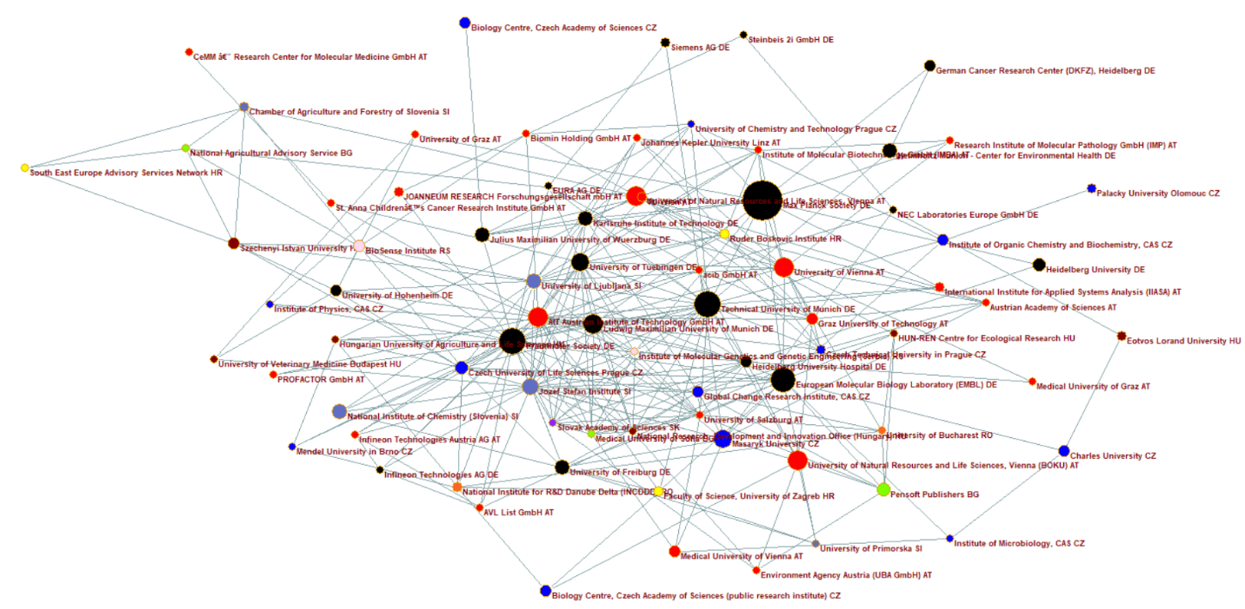
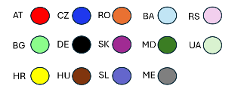
Source: Author's visualization using Pajek software

The table 3 provides a detailed quantitative analysis of the collaboration network for Agri-Food, Bioeconomy & Biotechnology area in the Danube Region, focusing on key centrality measures. It lists the organizations involved, their number of project participations, and three centrality indicators: degree centrality, closeness centrality, and betweenness centrality. These metrics offer insights into the influence, connectivity, and strategic importance of each organization within the network. The number of projects indicates an organization's overall participation in Horizon Europe environmental research initiatives.
Degree Centrality
Degree centrality highlights the number of direct connections an organization has within the network, serving as an indicator of its collaborative capacity. Fraunhofer Society holds the highest degree (33) and confirms its role as the most important hub for cross-border cooperation in the Danube AgriFood-Bioeconomy-Biotech research network. It is followed by the Technical University of Munich (23) and the Jožef Stefan Institute (23) as well as the AIT Austrian Institute of Technology (23) and the University of Tubingen (19). A particularly interesting is the University of Salzburg (16), which achieves a high degree with only three projects, indicating an unusually large variety of partners per project and a strong convening capacity.
The Max Planck Society is the leader in the number of projects (62), but shows only moderate degree (14). This pattern suggests that the scope of cooperation in the Danube region is smaller. This may mean that this organisation targets other regions rather than extending links within the Danube region. As a result, the overall impact on network integration in this region is less than the sheer number of projects would suggest.
Among the non-EU countries, the Biosense Institute and the Institute of Molecular Genetics and Genetic Engineering from Serbia play a remarkable role. With only five and three projects, but a degree of 9 and 12 respectively, they are able to establish a wide range of collaborations. This demonstrates their position as a link between the regional and EU-wide biotechnology research communities. Such institutions contribute to integration even without large project portfolios by connecting partners from peripheral or less represented areas, thus strengthening the overall network structure.
Closeness Centrality
Closeness centrality measures how efficiently an organisation can access and disseminate information within the network. Fraunhofer Society (0.581) again takes the lead, underscoring its role as the network’s fastest conduit for information flow and coordination. Technical University of Munich (0.543) and AIT Austrian Institute of Technology (0.536) follow closely, confirming the dominance of the German–Austrian innovation axis not only in connectivity, but also in rapid dissemination capacity.
Among universities, Jožef Stefan Institute (0.517), University of Tübingen (0.500) and LMU Munich (0.497) perform strongly, reflecting their ability to act as efficient intermediaries within multinational research clusters. Interestingly, the University of Salzburg (0.493) matches this profile, despite its very limited project volume. Its high closeness score shows that even smaller players can position themselves strategically, enabling them to access and transmit knowledge quickly across the network.
The Institute of Molecular Genetics and Genetic Engineering (Serbia) (0.475) achieves closeness values comparable to much larger universities, reflecting its integration into well-connected consortia. This suggests that targeted support could amplify its role as a regional connector.
Betweenness Centrality
Betweenness centrality identifies organizations that act as bridges, connecting disparate clusters within the network. Once again, Fraunhofer Society (0.215) dominates, reflecting its important role in enabling collaboration across geographic boundaries. AIT (0.134) and Technical University of Munich (0.124) also score highly, consolidating their reputation as regional brokers with both scientific and applied focus.
Some actors show high brokerage efficiency, achieving strong betweenness despite having relatively few projects or partners. The University of Natural Resources and Life Sciences, Vienna, for example, has limited direct connections, but those links bridge otherwise distant clusters and give it disproportionate influence in the network. Similarly, the Chamber of Agriculture and Forestry of Slovenia acts as a rare practice-oriented broker, connecting applied agriculture with upstream research communities.
Conversely, Max Planck Society (0.081) show relatively modest betweenness given their scale. This reinforces the earlier observation: Max Planck tends to collaborate intensively within closed circles, and while it leads in project numbers, its ability to connect otherwise unlinked groups in the Danube region is limited.

Table 3: Key metrics from the social network analysis of Agri-Food, Bioeconomy & Biotechnology Horizon Europe projects in the Danube region
rn | Institution | Number of projects | Degree centralization | Closeness centrality | Betweenness centrality
1 | Max Planck Society (Germany) | 62 | 14 | 0.463 | 0.081
2 | Technical University of Munich (Germany) | 29 | 23 | 0.543 | 0.124
3 | Fraunhofer Society (Germany) | 28 | 33 | 0.581 | 0.215
4 | European Molecular Biology Laboratory (Germany) | 25 | 15 | 0.490 | 0.099
5 | University of Vienna (Austria) | 16 | 16 | 0.481 | 0.057
6 | AIT Austrian Institute of Technology GmbH (Austria) | 15 | 23 | 0.536 | 0.134
7 | Ludwig Maximilian University of Munich (Germany) | 15 | 15 | 0.497 | 0.026
8 | University of Natural Resources and Life Sciences, Vienna (Austria) | 15 | 5 | 0.361 | 0.082
9 | Masaryk University (Czech Republic) | 14 | 11 | 0.444 | 0.021
10 | University of Tuebingen (Germany) | 13 | 19 | 0.500 | 0.048
11 | Jozef Stefan Institute (Slovenia) | 11 | 23 | 0.517 | 0.068
12 | University of Freiburg (Germany) | 10 | 9 | 0.436 | 0.009
13 | Karlsruhe Institute of Technology (Germany) | 10 | 13 | 0.475 | 0.029
14 | National Institute of Chemistry (Slovenia) | 10 | 4 | 0.395 | 0.000
15 | Helmholtz Munich – Center for Environmental Health (Germany) | 10 | 2 | 0.357 | 0.003
16 | University of Ljubljana (Slovenia) | 9 | 16 | 0.460 | 0.015
17 | Julius Maximilian University of Wuerzburg (Germany) | 9 | 6 | 0.431 | 0.031
18 | Pensoft Publishers (Bulgaria) | 8 | 7 | 0.401 | 0.010
19 | Czech University of Life Sciences Prague (Czech Republic) | 7 | 14 | 0.466 | 0.024
20 | Heidelberg University (Germany) | 7 | 2 | 0.357 | 0.000
21 | Medical University of Vienna (Austria) | 6 | 4 | 0.364 | 0.004
22 | Institute of Organic Chemistry and Biochemistry, Czech Academy of Sciences (Czech Republic) | 6 | 4 | 0.399 | 0.029
23 | Charles University (Czech Republic) | 6 | 3 | 0.341 | 0.009
24 | Biosense Institute (Serbia) | 5 | 9 | 0.448 | 0.043
25 | Global Change Research Institute, Czech Acad. of Sc. (Czech Republic) | 5 | 10 | 0.441 | 0.014
26 | Heidelberg University Hospital (Germany) | 5 | 13 | 0.469 | 0.027
27 | Graz University of Technology (Austria) | 5 | 11 | 0.446 | 0.027
28 | German Cancer Research Center (Germany) | 5 | 2 | 0.321 | 0.001
29 | Ruder Boskovic Institute (Croatia) | 4 | 11 | 0.434 | 0.008
30 | National Institute for Research and Development (Romania) | 4 | 7 | 0.412 | 0.013
31 | International Institute for Applied Systems Analysis (Austria) | 4 | 3 | 0.381 | 0.000
32 | Czech Technical University in Prague (Czech Republic) | 4 | 8 | 0.424 | 0.008
33 | TU Wien (Austria) | 4 | 7 | 0.419 | 0.006
34 | Faculty of Science, University of Zagreb (Croatia) | 4 | 7 | 0.424 | 0.018
35 | Eotvos Lorand University (Hungary) | 4 | 2 | 0.296 | 0.002
36 | Siemens AG (Germany) | 4 | 2 | 0.311 | 0.000
37 | JOANNEUM RESEARCH Forschungsgesellschaft mbH (Austria) | 4 | 3 | 0.379 | 0.013
38 | Palacky University Olomouc (Czech Republic) | 4 | 1 | 0.286 | 0.000
39 | Infineon Technologies Austria AG (Austria) | 3 | 5 | 0.405 | 0.000
40 | Infineon Technologies AG (Germany) | 3 | 5 | 0.405 | 0.000
41 | National Research, Development and Innovation Office (Hungary) | 3 | 12 | 0.466 | 0.008
42 | Slovak Academy of Sciences (Slovakia) | 3 | 12 | 0.466 | 0.008
43 | EURA AG (Germany) | 3 | 5 | 0.417 | 0.012
44 | Medical University of Sofia (Bulgaria) | 3 | 12 | 0.469 | 0.008
45 | University of Salzburg (Austria) | 3 | 16 | 0.493 | 0.043
46 | Institute of Physics, Czech Academy of Sciences (Czech Republic) | 3 | 3 | 0.383 | 0.001
47 | Research Institute of Molecular Pathology GmbH (Austria) | 3 | 3 | 0.357 | 0.000
48 | South East Europe Advisory Services Network (Croatia) | 3 | 2 | 0.214 | 0.000
49 | Chamber of Agriculture and Forestry of Slovenia (Slovenia) | 3 | 3 | 0.270 | 0.053
50 | Institute of Molecular Biotechnology GmbH (Austria) | 3 | 8 | 0.397 | 0.004
51 | HUN-REN Centre for Ecological Research (Hungary) | 3 | 5 | 0.379 | 0.016
52 | acib GmbH (Austria) | 3 | 7 | 0.434 | 0.018
53 | Mendel University in Brno (Czech Republic) | 3 | 4 | 0.397 | 0.000
54 | Hungarian University of Agriculture and Life Sciences (Hungary) | 3 | 6 | 0.421 | 0.034
55 | Environment Agency Austria (Austria) | 3 | 4 | 0.355 | 0.001
56 | Institute of Molecular Genetics and Genetic Engineering (Serbia) | 3 | 12 | 0.475 | 0.004
57 | Austrian Academy of Sciences (Austria) | 3 | 6 | 0.373 | 0.001
58 | Institute of Microbiology, Czech Academy of Sciences (Czech Republic) | 3 | 3 | 0.341 | 0.002
59 | Medical University of Graz (Austria) | 3 | 2 | 0.354 | 0.000
60 | Szechenyi Istvan University (Hungary) | 3 | 2 | 0.214 | 0.000
61 | University of Primorska (Slovenia) | 3 | 4 | 0.359 | 0.001
62 | University of Chemistry and Technology Prague (Czech Republic) | 3 | 7 | 0.421 | 0.043
63 | University of Hohenheim (Germany) | 3 | 4 | 0.383 | 0.008
64 | University of Graz (Austria) | 3 | 3 | 0.344 | 0.004
65 | University of Veterinary Medicine Budapest (Hungary) | 3 | 3 | 0.354 | 0.003
66 | Johannes Kepler University Linz (Austria) | 3 | 6 | 0.385 | 0.000
67 | Steinbeis 2i GmbH (Germany) | 3 | 2 | 0.296 | 0.001
68 | NEC Laboratories Europe GmbH (Germany) | 3 | 4 | 0.385 | 0.031
69 | St. Anna Children’s Cancer Research Institute GmbH (Austria) | 3 | 3 | 0.369 | 0.027
70 | CeMM – Research Center for Molecular Medicine (Austria) | 3 | 1 | 0.271 | 0.000
71 | University of Bucharest (Romania) | 3 | 6 | 0.403 | 0.007
72 | PROFACTOR GmbH (Austria) | 3 | 2 | 0.393 | 0.000
73 | AVL List GmbH (Austria) | 3 | 5 | 0.393 | 0.001
74 | Biomin Holding GmbH (Austria) | 3 | 3 | 0.385 | 0.017
75 | Biology Centre, Czech Academy of Sciences (Czech Republic) | 3 | 1 | 0.302 | 0.000
Source: cordis database
Note: the table includes only organizations from the Danube region that have participated in at least three Horizon Europe projects
The colour coding in the table represents different levels of performance: green cells indicate higher values, signifying strong participation and centrality within the network. Red cells highlight lower values, pointing to weaker integration and limited engagement in Horizon Europe projects.

Research cooperation in ICT and Digitalisation
The ICT and Digitalisation cooperation network in the Danube Region shows a robust and more interconnected structure than the Agri-Food, Bioeconomy & Biotechnology network (Figure 6). A significant number of organisations participate in Horizon Europe projects, and the level of interlinkage is comparatively stronger. Nevertheless, the network is still characterised by a concentration of activity around a limited number of dominant institutions, which act as central hubs for regional collaboration.
As in other domains, large and well-established research organisations lead the network. The Fraunhofer Society (Germany) occupies the most central position, with 92 project participations and the highest values for degree, closeness, and betweenness centrality (Table 4). Other major actors include the Technical University of Munich (Germany, 52 projects) and the Max Planck Society for the Advancement of Science (Germany, 35 projects), both of which leverage their size and resources to shape research directions and ensure knowledge exchange across multiple ICT domains, including artificial intelligence, the Internet of Things, data science, and cybersecurity.
The geographical distribution of the network reflects once again the dominance of Germany and Austria, which host several of the central hubs. Slovenia also shows strong representation through the Jožef Stefan Institute, while organisations from Romania and Serbia appear as emerging contributors. These organisations, while more peripheral in the network, add thematic diversity and broaden the scope of regional collaboration.

Figure 6: ICT and Digitalisation Cooperation Network in the Danube Region (Horizon Europe)
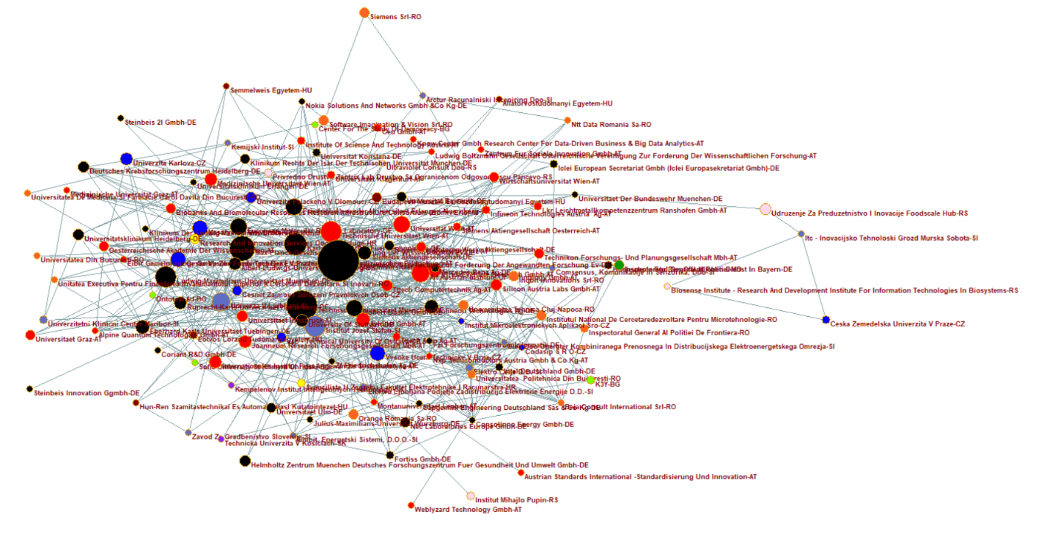
Source: Author's visualization using Pajek software

Degree Centrality
The Fraunhofer Society for the Promotion of Applied Research (Germany) leads with the highest degree centrality (81), reflecting its role as a central hub in ICT and Digitalisation collaboration across the Danube Region. Similarly, the Technical University of Munich (Germany) (41) and the Karlsruhe Institute of Technology (Germany) (36) exhibit strong connectivity, underscoring their influence in fostering partnerships and sustaining an extensive research network. In comparison, the FZI Research Center for Information Technology (Germany) participates in only three Horizon Europe projects but reaches a degree centrality of 23, showing that it maintains direct collaborative links with a relatively large number of partners. This illustrates that centrality does not depend solely on the volume of projects, but also on the breadth of connections established through those projects
Organizations from the downstream Danube countries record much lower degree centrality values, which points to their limited integration into the regional research network in the area of ICT and Digitalisation and reveals structural imbalances in participation and connectivity across the Danube Region.
Closeness Centrality
The Fraunhofer Society for the Promotion of Applied Research demonstrates the highest closeness centrality (0.711), which underlines its role as a strategic channel for information flow and collaboration. The Technical University of Munich (0.559), the Vienna University of Technology (Austria) (0.522) and the Jožef Stefan Institute (Slovenia) (0.520) also rank highly.
In contrast, several organizations with a considerable number of projects have relatively low closeness centrality scores, including Charles University (Czech Republic), the International Institute for Applied Systems Analysis (Austria) and Helmholtz Zentrum München, German Research Center for Environmental Health (Germany). Although these institutions actively participate in Horizon Europe projects, their collaborations are located at the periphery of the network, making them less directly connected to most other actors and reducing their overall influence on the cohesion and efficiency of regional cooperation in this area.
Betweenness Centrality
The Fraunhofer Society for the Promotion of Applied Research (0.432) again emerges as the dominant player, enabling the flow of knowledge and collaboration across thematic and geographical divides. The Technical University of Munich (0.083) and the Karlsruhe Institute of Technology (0.073) also play significant bridging roles, linking various subfields and facilitating interdisciplinary research.
Interestingly, the Foodscale Hub (Serbia) demonstrates noteworthy betweenness centrality despite its lower degree centrality. This highlights its unique role as a bridge within specific clusters, showcasing its potential to connect smaller, specialized organizations to larger research networks.
Table 4: Key Metrics from the Social network analysis of ICT and Digitalisation Horizon Europe projects in the Danube region
r.n. | Institution | Number of projects | Degree centralization | Closeness centrality | Betweenness centrality
1 | Fraunhofer Society for the Promotion of Applied Research (Germany) | 92 | 81 | 0.711 | 0.432
2 | Technical University of Munich (Germany) | 52 | 41 | 0.559 | 0.083
3 | Max Planck Society for the Advancement of Science (Germany) | 35 | 24 | 0.518 | 0.027
4 | Karlsruhe Institute of Technology (Germany) | 30 | 36 | 0.554 | 0.073
5 | Ludwig Maximilian University of Munich (Germany) | 26 | 16 | 0.472 | 0.011
6 | Jožef Stefan Institute (Slovenia) | 25 | 28 | 0.520 | 0.032
7 | Vienna University of Technology (Austria) | 25 | 28 | 0.522 | 0.040
8 | AIT Austrian Institute of Technology GmbH (Austria) | 20 | 27 | 0.514 | 0.038
9 | University of Ljubljana (Slovenia) | 19 | 31 | 0.533 | 0.070
10 | University of Vienna (Austria) | 17 | 20 | 0.500 | 0.044
11 | Friedrich-Alexander University Erlangen-Nuremberg (Germany) | 16 | 20 | 0.504 | 0.025
12 | European Molecular Biology Laboratory (Germany) | 16 | 17 | 0.494 | 0.013
13 | Robert Bosch GmbH (Germany) | 15 | 33 | 0.533 | 0.027
14 | Graz University of Technology (Austria) | 15 | 25 | 0.512 | 0.016
15 | Masaryk University (Czech Republic) | 14 | 16 | 0.481 | 0.011
16 | Czech Technical University in Prague (Czech Republic) | 13 | 9 | 0.462 | 0.003
17 | Brno University of Technology (Czech Republic) | 13 | 27 | 0.506 | 0.015
18 | Virtual Vehicle Research GmbH (Austria) | 12 | 24 | 0.508 | 0.004
19 | AVL List GmbH (Austria) | 12 | 26 | 0.516 | 0.007
20 | Siemens AG (Germany) | 12 | 13 | 0.476 | 0.004
21 | Infineon Technologies AG – (Germany) | 11 | 29 | 0.516 | 0.012
22 | University of Tübingen (Germany) | 11 | 15 | 0.437 | 0.007
23 | Heidelberg University (Germany) | 10 | 19 | 0.479 | 0.013
24 | Charles University (Czech Republic) | 10 | 7 | 0.404 | 0.001
25 | University of Freiburg (Germany) | 9 | 13 | 0.487 | 0.008
26 | University of Stuttgart (Germany) | 9 | 21 | 0.492 | 0.021
27 | Medical University of Vienna (Austria) | 9 | 16 | 0.465 | 0.014
28 | JOANNEUM RESEARCH Forschungsgesellschaft mbH (Austria) | 9 | 10 | 0.460 | 0.004
29 | International Institute for Applied Systems Analysis (Austria) | 9 | 4 | 0.440 | 0.000
30 | German Cancer Research Center, Heidelberg (Germany) | 8 | 8 | 0.372 | 0.001
31 | Helmholtz Zentrum München German Research Center for Environmental Health (Germany) | 8 | 2 | 0.375 | 0.000
32 | Palacký University Olomouc (Czech Republic) | 8 | 11 | 0.476 | 0.003
33 | University of Innsbruck (Austria) | 8 | 14 | 0.452 | 0.005
34 | Silicon Austria Labs GmbH (Austria) | 7 | 24 | 0.490 | 0.009
35 | TTTech Computertechnik AG (Austria) | 7 | 25 | 0.508 | 0.006
36 | Heidelberg University Hospital (Germany) | 7 | 6 | 0.389 | 0.002
37 | Foodscale Hub (Serbia) | 7 | 2 | 0.312 | 0.046
38 | Budapest University of Technology and Economics (Hungary) | 6 | 16 | 0.472 | 0.007
39 | General Inspectorate of the Police (Moldova) | 6 | 5 | 0.368 | 0.000
40 | INQBIT Innovations SRL (Romania) | 6 | 7 | 0.446 | 0.005
41 | Technical University of Ostrava (Czech Republic) | 6 | 17 | 0.485 | 0.002
42 | Software Imagination & Vision SRL (Romania) | 6 | 3 | 0.424 | 0.013
43 | Research and Innovation Services Ltd. for Services (Croatia) | 6 | 14 | 0.472 | 0.005
44 | University of Bayreuth (Germany) | 6 | 10 | 0.474 | 0.012
45 | University of Graz (Austria) | 6 | 3 | 0.361 | 0.000
46 | University of Ulm (Germany) | 6 | 9 | 0.403 | 0.003
47 | Johannes Kepler University Linz (Austria) | 6 | 12 | 0.469 | 0.003
48 | Biobanks and Biomolecular Resources Research Infrastructure Consortium (BBMRI-ERIC) (Austria) | 5 | 10 | 0.465 | 0.003
49 | BMW AG (Germany) | 5 | 18 | 0.490 | 0.001
50 | Rechts der Isar Hospital, Technical University of Munich (Germany) | 5 | 5 | 0.438 | 0.001
51 | National Institute for Research and Development in Microtechnology (Romania) | 5 | 11 | 0.448 | 0.001
52 | Vienna University of Economics and Business (Austria) | 5 | 10 | 0.448 | 0.003
53 | NEC Laboratories Europe GmbH (Germany) | 5 | 5 | 0.373 | 0.001
54 | CESNET, Interest Association of Legal Entities (Czech Republic) | 5 | 11 | 0.485 | 0.005
55 | Technical University of Cluj-Napoca (Romania) | 5 | 6 | 0.448 | 0.001
56 | Austrian Academy of Sciences (Austria) | 5 | 11 | 0.410 | 0.002
57 | Siemens SRL (Romania) | 5 | 2 | 0.306 | 0.000
58 | Technikon Research and Planning Company (Austria) | 5 | 3 | 0.430 | 0.000
59 | Orange Romania SA (Romania) | 5 | 2 | 0.420 | 0.002
60 | Mercedes-Benz AG (Germany) | 4 | 22 | 0.500 | 0.002
61 | TTTech Auto AG (Austria) | 4 | 20 | 0.492 | 0.001
62 | Zentrix Lab Ltd. Pančevo (Serbia) | 4 | 9 | 0.459 | 0.003
63 | University of Applied Sciences for Public Service in Bavaria (Germany) | 4 | 5 | 0.368 | 0.000
64 | Elektro Celje d.d. (Slovenia) | 4 | 9 | 0.443 | 0.003
65 | General Inspectorate of Border Police (Romania) | 4 | 5 | 0.388 | 0.002
66 | University of Konstanz (Germany) | 4 | 4 | 0.432 | 0.000
67 | University of Klagenfurt (Austria) | 4 | 5 | 0.438 | 0.000
68 | Politehnica University of Bucharest (Romania) | 4 | 14 | 0.454 | 0.002
69 | LKR Light Metal Competence Center (Austria) | 4 | 2 | 0.425 | 0.000
70 | Infineon Technologies Austria AG (Austria) | 4 | 14 | 0.467 | 0.010
71 | Fortiss GmbH (Germany) | 4 | 6 | 0.382 | 0.000
72 | K3Y (Bulgaria) | 4 | 3 | 0.343 | 0.000
73 | Elektro Ljubljana d.d. (Slovenia) | 4 | 8 | 0.449 | 0.017
74 | Intel Deutschland GmbH (Germany) | 4 | 14 | 0.452 | 0.019
75 | University of Zagreb, Faculty of Electrical Engineering and Computing (Croatia) | 4 | 6 | 0.440 | 0.000
76 | Siemens AG Austria (Austria) | 4 | 11 | 0.464 | 0.007
77 | Eötvös Loránd University (Hungary) | 4 | 10 | 0.464 | 0.005
78 | University Medical Centre Maribor (Slovenia) | 4 | 3 | 0.370 | 0.001
79 | ICLEI European Secretariat (Germany) | 4 | 4 | 0.369 | 0.001
80 | Mihajlo Pupin Institute (Serbia) | 4 | 1 | 0.311 | 0.000
81 | CEU GmbH (Austria) | 4 | 3 | 0.424 | 0.000
82 | Czech University of Life Sciences Prague (Czech Republic) | 4 | 2 | 0.194 | 0.000
83 | Institute of Science and Technology Austria (Austria) | 4 | 4 | 0.435 | 0.000
84 | ZF Friedrichshafen AG (Germany) | 3 | 14 | 0.472 | 0.000
85 | Ultraviolet Consult d.o.o. (Serbia) | 3 | 6 | 0.443 | 0.001
86 | LMU University Hospital Munich (Germany) | 3 | 5 | 0.443 | 0.000
87 | FZI Research Center for Information Technology (Germany) | 3 | 23 | 0.490 | 0.006
88 | HUN-REN Institute for Computer Science and Automation (Hungary) | 3 | 4 | 0.389 | 0.001
89 | NXP Semiconductors Austria GmbH & Co KG (Austria) | 3 | 15 | 0.471 | 0.003
90 | Semmelweis University (Hungary) | 3 | 4 | 0.370 | 0.000
91 | Alpine Quantum Technologies GmbH (Austria) | 3 | 9 | 0.413 | 0.000
92 | University of Leoben (Austria) | 3 | 12 | 0.416 | 0.001
93 | Institute of Microelectronic Applications (Czech Republic) | 3 | 15 | 0.471 | 0.002
94 | Ludwig Boltzmann Society (Austria) | 3 | 4 | 0.432 | 0.000
95 | Amibit, energetski sistemi, d.o.o. (Slovenia) | 3 | 8 | 0.412 | 0.002
96 | Capgemini Engineering Deutschland SAS & Co KG (Germany) | 3 | 2 | 0.420 | 0.000
97 | European Institute for Biomedical Imaging Research (Austria) | 3 | 3 | 0.428 | 0.000
98 | Consolinno Energy GmbH (Germany) | 3 | 15 | 0.405 | 0.004
99 | Carol Davila University of Medicine and Pharmacy (Romania) | 3 | 2 | 0.354 | 0.001
100 | University of Bucharest (Romania) | 3 | 2 | 0.370 | 0.000
101 | Sofia University St. Kliment Ohridski (Bulgaria) | 3 | 5 | 0.434 | 0.001
102 | Codasip s.r.o. (Czech Republic) | 3 | 13 | 0.410 | 0.002
103 | webLyzard technology GmbH (Austria) | 3 | 1 | 0.312 | 0.000
104 | ELES d.o.o., Operator of the Combined Transmission and Distribution Electricity Network (Slovenia) | 3 | 9 | 0.448 | 0.002
105 | Ontotext AD (Bulgaria) | 3 | 7 | 0.444 | 0.002
106 | Steinbeis 2i GmbH (Germany) | 3 | 2 | 0.356 | 0.000
107 | Erlangen University Hospital (Germany) | 3 | 6 | 0.440 | 0.002
108 | Centre for Social Innovation (Austria) | 3 | 2 | 0.420 | 0.001
109 | Slovenian National Building and Civil Engineering Institute (Slovenia) | 3 | 3 | 0.375 | 0.000
110 | Medical University of Graz (Austria) | 3 | 5 | 0.367 | 0.001
111 | NTT Data Romania SA (Romania) | 3 | 4 | 0.340 | 0.000
112 | Arctur Computer Engineering Ltd. (Slovenia) | 3 | 4 | 0.372 | 0.006
113 | Nokia Solutions and Networks GmbH & Co KG (Germany) | 3 | 5 | 0.374 | 0.000
114 | Executive Unit for Financing Higher Education, Research, Development, and Innovation (Romania) | 3 | 4 | 0.379 | 0.000
115 | Julius Maximilian University of Würzburg (Germany) | 3 | 3 | 0.388 | 0.000
116 | Kempelen Institute of Intelligent Technologies (Slovakia) | 3 | 6 | 0.443 | 0.001
117 | University of the Federal Armed Forces Munich (Germany) | 3 | 4 | 0.443 | 0.061
118 | ITC - Innovation and Technology Cluster Murska Sobota (Slovenia) | 3 | 3 | 0.240 | 0.031
119 | Steinbeis Innovation (Germany) | 3 | 1 | 0.349 | 0.000
120 | Technical University of Košice (Slovakia) | 3 | 3 | 0.369 | 0.000
121 | 116. Know-Center GmbH (Austria) | 3 | 2 | 0.424 | 0.000
122 | Comsensus, Communications and Sensorics Ltd. (Slovenia) | 3 | 5 | 0.430 | 0.002
123 | Coriant R&D GmbH (Germany) | 3 | 2 | 0.427 | 0.000
124 | Center for the Study of Democracy (Bulgaria) | 3 | 2 | 0.418 | 0.000
125 | National Institute of Chemistry (Slovenia) | 3 | 4 | 0.430 | 0.001
126 | Austrian Standards International – Standardization and Innovation (Austria) | 3 | 1 | 0.331 | 0.000
127 | BEIA Consult International SRL (Romania) | 3 | 11 | 0.376 | 0.002
128 | University of Veterinary Medicine Budapest (Hungary) | 3 | 2 | 0.348 | 0.000
129 | BioSense Institute (Serbia) | 3 | 2 | 0.194 | 0.000
Source: cordis database
Note: the table includes only organizations from the Danube region that have participated in at least three Horizon Europe projects
The colour coding in the table represents different levels of performance: green cells indicate higher values, signifying strong participation and centrality within the network. Red cells highlight lower values, pointing to weaker integration and limited engagement in Horizon Europe projects.

Research cooperation in Climate and Energy area
As in the ICT and Digitalisation research domain, the Climate and Energy collaboration network in the Danube Region also exhibits a robust structure, highlighting the presence of strong cooperative ties among organizations engaged in Horizon Europe projects. However, compared to the ICT and Digitalisation network, this collaboration network is less dense, with fewer participating organizations and projects, indicating a relatively lower level of interconnectedness.
There is the prominence of a few central organizations that act as significant hubs within the network. Fraunhofer Society for the Promotion of Applied Research (Germany) and the Karlsruhe Institute of Technology (Germany) stand out as the most visible institutions, as indicated by their large node sizes and extensive connectivity (Figure 7). These institutions not only lead in the number of collaborations but also play an important role in bridging various clusters of organizations, facilitating communication and resource sharing across the network.
The visualization highlights the geographical distribution of collaboration across the region. Germany and Austria dominate the network, with several organizations occupying central positions, while actors from Moldova, Montenegro, and Bosnia and Herzegovina appear largely at the periphery. This points to an imbalance in collaboration intensity, where well-funded institutions from stronger research systems concentrate at the core, whereas smaller organizations from emerging economies remain less integrated into the network.
Figure 7: Climate and Energy Area Cooperation Network in the Danube Region (Horizon Europe)
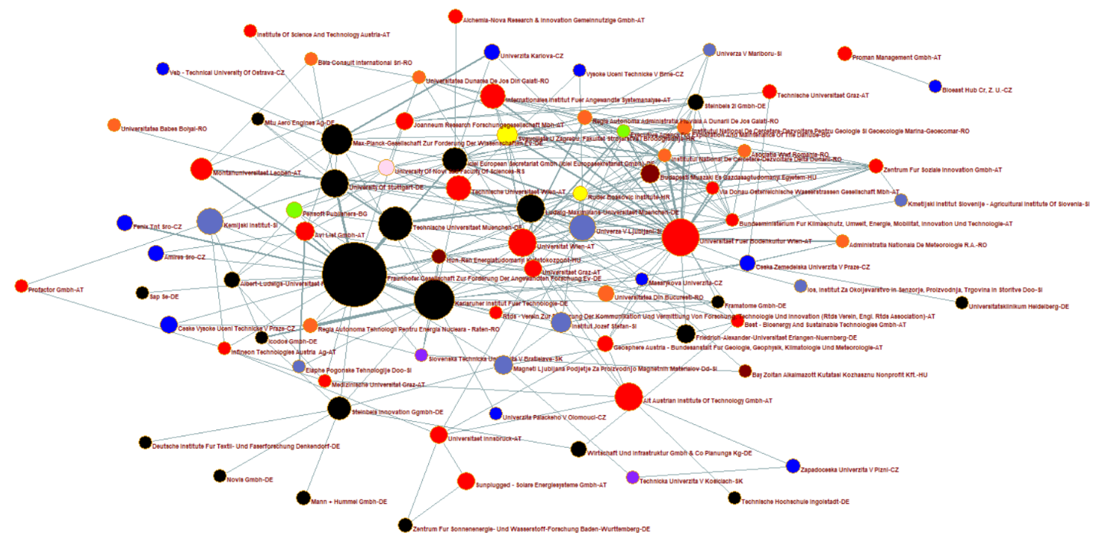
Source: Author's visualization using Pajek software
The table 5 It lists the organizations involved in the Climate and Energy area cooperation network, their number of project participations, and three centrality indicators: degree centrality, closeness centrality, and betweenness centrality. The Fraunhofer Society for the Promotion of Applied Research (Germany) leads the table with 75 projects, followed by the Karlsruhe Institute of Technology (Germany) with 29 and the University of Natural Resources and Life Sciences, Vienna (Austria) with 25. These institutions demonstrate strong capacities in securing funding and active engagement in collaborative research. Interestingly, many organizations with fewer total projects, such as the Jožef Stefan Institute (Slovenia) and the Ruđer Bošković Institute (Croatia), maintain notable positions in centrality measures, highlighting the importance of not only the quantity of participation but also the quality and connectivity of their collaborations.
Degree Centrality
The University of Natural Resources and Life Sciences, Vienna (BOKU) stands out with the highest degree centrality (29), indicating its extensive direct partnerships. Similarly, the Fraunhofer Society for the Promotion of Applied Research (26) and the Karlsruhe Institute of Technology (20) also exhibit high degree centrality, reinforcing their hub-like roles in the network. On the other side, the National Institute for Research and Development in the Danube Delta (Romania) and the Executive Agency for Exploration and Maintenance of the Danube (Bulgaria), demonstrate lower degree centrality values. This suggests that while they participate in significant projects, they maintain a limited number of direct collaborative links, potentially restricting their influence within the network.
Closeness Centrality
The Fraunhofer Society for the Promotion of Applied Research (0.545) leads this metric, underlining its role as a central and well-integrated entity in the network. Institutions like the University of Natural Resources and Life Sciences, Vienna (0.504) and the University of Vienna (0.500) are also strategically well-placed, enabling them to efficiently disseminate knowledge and collaborate across the network. An interesting observation is the high closeness centrality of organizations like the Jožef Stefan Institute (Slovenia) and the National Institute for Research and Development in the Danube Delta (Romania), despite their relatively lower project participation. This suggests that these institutions occupy strategically advantageous positions, allowing them to act as key facilitators of collaboration.
Betweenness Centrality
The Fraunhofer Society for the Promotion of Applied Research (0.264) and the Karlsruhe Institute of Technology (0.162) exhibit the highest betweenness values, indicating their critical roles as intermediaries in connecting different clusters within the network. The Jožef Stefan Institute (Slovenia) and the Ruđer Bošković Institute (Croatia) also show relatively high betweenness values despite fewer project participations, suggesting that they play key bridging roles in connecting central parts of the network to larger hubs. This highlights their importance in promoting inclusivity and knowledge-sharing across the region.
Table 5: Key Indicators from the Social Network Analysis of Environmental Research in the Danube Region
r.n. | Institution | Number of projects | Degree centralization | Closeness centrality | Betweenness centrality
1 | Fraunhofer Society for the Promotion of Applied Research (Germany) | 75 | 26 | 0.545 | 0.264
2 | Karlsruhe Institute of Technology (Germany) | 29 | 20 | 0.520 | 0.162
3 | University of Natural Resources and Life Sciences, Vienna (Austria) | 25 | 29 | 0.504 | 0.152
4 | Technical University of Munich (Germany) | 22 | 10 | 0.445 | 0.018
5 | Max Planck Society for the Advancement of Science (Germany) | 17 | 10 | 0.415 | 0.062
6 | University of Stuttgart (Germany) | 15 | 10 | 0.435 | 0.055
7 | Ludwig Maximilian University of Munich (Germany) | 15 | 8 | 0.404 | 0.010
8 | University of Vienna (Austria) | 14 | 18 | 0.500 | 0.076
9 | AIT Austrian Institute of Technology GmbH (Austria) | 14 | 7 | 0.366 | 0.051
10 | University of Ljubljana (Slovenia) | 13 | 21 | 0.504 | 0.121
11 | National Institute of Chemistry (Slovenia) | 13 | 7 | 0.402 | 0.027
12 | Vienna University of Technology (Austria) | 11 | 6 | 0.391 | 0.010
13 | ICLEI European Secretariat (Germany) | 11 | 11 | 0.445 | 0.044
14 | International Institute for Applied Systems Analysis (Austria) | 11 | 7 | 0.391 | 0.010
15 | Steinbeis Innovation (Germany) | 10 | 8 | 0.404 | 0.084
16 | University of Leoben (Austria) | 9 | 4 | 0.374 | 0.008
17 | University of Zagreb, Faculty of Mechanical Engineering and Naval Architecture (Croatia) | 8 | 11 | 0.415 | 0.015
18 | Jožef Stefan Institute (Slovenia) | 8 | 8 | 0.409 | 0.014
19 | AVL List GmbH (Austria) | 7 | 6 | 0.404 | 0.012
20 | Magneti Ljubljana Company for the Production of Magnetic Materials (Slovenia) | 7 | 6 | 0.419 | 0.035
21 | Budapest University of Technology and Economics (Hungary) | 7 | 15 | 0.413 | 0.022
22 | Friedrich-Alexander University Erlangen-Nuremberg (Germany) | 7 | 5 | 0.389 | 0.003
23 | University of Graz (Austria) | 6 | 10 | 0.447 | 0.048
24 | University of Innsbruck (Austria) | 6 | 6 | 0.348 | 0.051
25 | Solare Energiesysteme GmbH (Austria) | 6 | 2 | 0.258 | 0.000
26 | Czech Technical University in Prague (Czech Republic) | 6 | 2 | 0.353 | 0.000
27 | JOANNEUM RESEARCH Forschungsgesellschaft mbH (Austria) | 6 | 4 | 0.387 | 0.014
28 | Fenix TNT s.r.o. (Czech Republic) | 5 | 1 | 0.351 | 0.000
29 | Charles University (Czech Republic) | 5 | 3 | 0.376 | 0.001
30 | Steinbeis 2i GmbH (Germany) | 5 | 9 | 0.383 | 0.012
31 | Czech University of Life Sciences Prague (Czech Republic) | 5 | 6 | 0.396 | 0.037
32 | Pensoft Publishers (Bulgaria) | 5 | 6 | 0.413 | 0.005
33 | Wirtschaft und Infrastruktur GmbH & Co Planungs KG (Germany) | 5 | 2 | 0.318 | 0.001
34 | University of Freiburg (Germany) | 5 | 4 | 0.369 | 0.001
35 | University of Novi Sad Faculty of Sciences (Serbia) | 5 | 8 | 0.391 | 0.013
36 | University of Bucharest (Romania) | 5 | 4 | 0.406 | 0.008
37 | Amires s.r.o. (Czech Republic) | 5 | 2 | 0.361 | 0.000
38 | Federal Institute for Geology, Geophysics, Climatology, and Meteorology (Austria) | 5 | 6 | 0.426 | 0.026
39 | National Institute for Marine Geology and Geoecology - GeoEcoMar (Romania) | 4 | 15 | 0.419 | 0.006
40 | Autonomous Administration for Nuclear Energy Technologies (Romania) | 4 | 5 | 0.391 | 0.002
41 | Lower Danube River Administration (Romania) | 4 | 11 | 0.406 | 0.011
42 | Ruđer Bošković Institute (Croatia) | 4 | 16 | 0.438 | 0.019
43 | HUN-REN Centre for Energy Research (Hungary) | 4 | 10 | 0.438 | 0.013
44 | Centre for Social Innovation (Austria) | 4 | 11 | 0.396 | 0.003
45 | MANN+HUMMEL GmbH (Germany) | 4 | 1 | 0.287 | 0.000
46 | Graz University of Technology (Austria) | 4 | 2 | 0.307 | 0.001
47 | University of West Bohemia (Czech Republic) | 4 | 2 | 0.275 | 0.002
48 | Proman Management GmbH (Austria) | 4 | 1 | 0.024 | 0.000
49 | Centre for Solar Energy and Hydrogen Research Baden-Württemberg (Germany) | 4 | 2 | 0.258 | 0.000
50 | alchemia-nova Research & Innovation gemeinnützige GmbH (Austria) | 4 | 1 | 0.307 | 0.000
51 | National Institute for Research and Development in the Danube Delta (Romania) | 3 | 15 | 0.426 | 0.005
52 | Elaphe Propulsion Technologies (Slovenia) | 3 | 2 | 0.348 | 0.001
53 | Executive Agency for Exploration and Maintenance of the Danube (Bulgaria) | 3 | 15 | 0.433 | 0.009
54 | via donau - Austrian Waterway Company (Austria) | 3 | 13 | 0.415 | 0.002
55 | Icodos GmbH (Germany) | 3 | 3 | 0.366 | 0.002
56 | WWF Romania (Romania) | 3 | 12 | 0.406 | 0.005
57 | National Meteorological Administration (Romania) | 3 | 4 | 0.357 | 0.001
58 | Slovak University of Technology in Bratislava (Slovakia) | 3 | 5 | 0.391 | 0.005
59 | VŠB - Technical University of Ostrava (Czech Republic) | 3 | 1 | 0.292 | 0.000
60 | Brno University of Technology (Czech Republic) | 3 | 2 | 0.339 | 0.000
61 | University of Maribor (Slovenia) | 3 | 3 | 0.322 | 0.000
62 | Bay Zoltán Nonprofit Ltd. for Applied Research (Hungary) | 3 | 2 | 0.339 | 0.001
63 | Technical University of Košice (Slovakia) | 3 | 2 | 0.303 | 0.004
64 | German Institutes for Textile and Fiber Research Denkendorf (Germany) | 3 | 1 | 0.287 | 0.000
65 | Masaryk University (Czech Republic) | 3 | 5 | 0.413 | 0.002
66 | Agricultural Institute of Slovenia (Slovenia) | 3 | 2 | 0.335 | 0.000
67 | BEST - Bioenergy and Sustainable Technologies GmbH (Austria) | 3 | 5 | 0.383 | 0.010
68 | BIOEAST HUB CR, z. ú. (Czech Republic) | 3 | 1 | 0.024 | 0.000
69 | Novis GmbH (Germany) | 3 | 1 | 0.287 | 0.000
70 | Medical University of Graz (Austria) | 3 | 4 | 0.376 | 0.007
71 | Dunărea de Jos University of Galați (Romania) | 3 | 7 | 0.366 | 0.010
72 | BEIA Consult International SRL (Romania) | 3 | 3 | 0.324 | 0.001
73 | Babeș-Bolyai University (Romania) | 3 | 1 | 0.302 | 0.000
74 | MTU Aero Engines AG (Germany) | 3 | 3 | 0.330 | 0.001
75 | Heidelberg University Hospital (Germany) | 3 | 1 | 0.283 | 0.000
76 | RTDS Association (Austria) | 3 | 2 | 0.398 | 0.001
77 | Federal Ministry for Climate Action, Environment, Energy, Mobility, Innovation, and Technology (Austria) | 3 | 12 | 0.409 | 0.005
78 | SAP SE (Germany) | 3 | 1 | 0.351 | 0.000
79 | Framatome GmbH (Germany) | 3 | 4 | 0.376 | 0.001
80 | Ingolstadt University of Technology (Germany) | 3 | 1 | 0.267 | 0.000
81 | PROFACTOR GmbH (Austria) | 3 | 2 | 0.295 | 0.000
82 | Palacký University Olomouc (Czech Republic) | 3 | 1 | 0.341 | 0.000
83 | IOS Institute for Environmental Protection and Sensors (Slovenia) | 3 | 1 | 0.334 | 0.000
84 | Institute of Science and Technology Austria (Austria) | 3 | 1 | 0.292 | 0.000
85 | Infineon Technologies Austria AG (Austria) | 3 | 5 | 0.383 | 0.020
Source: cordis database
Note: the table includes only organizations from the Danube region that have participated in at least three Horizon Europe projects
The colour coding in the table represents different levels of performance: green cells indicate higher values, signifying strong participation and centrality within the network. Red cells highlight lower values, pointing to weaker integration and limited engagement in Horizon Europe projects.

Key Findings and Policy Recommendations

5.1. Summary of Key Findings
This study provides an analysis of patterns of research cooperation in the Danube region, based on participation in Horizon Europe projects, highlighting the role of S3 priorities in shaping regional innovation.
The analysis reveals significant differences in research participation in the Danube region. Countries such as Slovenia, Austria and Germany (Bavaria and Baden-Württemberg) show high per capita participation in Horizon Europe projects, indicating a well-developed research ecosystem and strong integration into European funding frameworks. In contrast, non-EU countries such as Ukraine, Bosnia and Herzegovina, Moldova and Montenegro have lower participation rates, indicating structural challenges in accessing research funding and forming international collaborations. The per capita analysis underlines that research excellence does not depend solely on the size of the country, but also on institutional capacity and strategic investment in research and innovation.
Agri-Food, Bioeconomy & Biotechnology, ICT and Digitalisation and Climate and Energy have been identified as the most common priority areas in Smart Specialisation Strategies across the Danube Region. It has been shown that these three areas represent critical drivers of transformative economic and technological progress in the region. Moreover, the results suggest that interdisciplinary collaboration between them, such as applying AI-driven tools in smart agriculture, integrating IoT-enabled energy grids, or developing bio-based innovations for sustainable resource use, could further enhance regional innovation potential and competitiveness.
The SNA has identified important research centres and cooperation patterns that reveal a highly structured network with prominent central institutions. Organisations such as the Fraunhofer Society for the Promotion of Applied Research (Germany), the Technical University of Munich (Germany), the Jožef Stefan Institute (Slovenia) and the Vienna University of Technology (Austria) act as important research centres. These institutions play a crucial role in driving research initiatives, promoting knowledge exchange and connecting smaller, peripheral organisations. The analysis also shows that Germany and Austria dominate the central positions in the research networks, but emerging players from Slovenia, Croatia and Serbia are becoming increasingly important. Institutions from less integrated regions take a peripheral role, highlighting the need for targeted capacity building efforts to bridge disparities.
Despite the strong research involvement of leading institutions, the study reveals persistent differences in research cooperation in the Danube region. Smaller institutions and non-EU countries face systemic obstacles such as weaker institutional capacity, which limit their ability to integrate into larger research networks. The findings highlight the need for policy measures that strengthen research collaboration through greater inclusivity and access to resources.
An important result of the analysis is the importance of bridging institutions in facilitating knowledge transfer. Organizations with a high degree of betweenness centrality, such as the Jožef Stefan Institute (Slovenia) and the Ruđer Bošković Institute (Croatia), serve as important links between smaller institutions and central research hubs. These institutions play a crucial role in promoting cross-border cooperation, improving regional cohesion and improving the overall connectivity of the research ecosystem in the S3 priority areas in the Region.
The results underline the need for strategic policy interventions to improve access to funding, support interdisciplinary research and promote cross-border institutional cooperation. Strengthening research collaboration through targeted investments and improved institutional frameworks is key to increasing regional integration and innovation impact.

5.2. Future Directions for Research Collaboration in the Danube Region
The Danube Region has immense potential to play a leading role in research cooperation and innovation by building on its existing strengths and addressing current disparities. To fully exploit the potential of research and innovation in the Danube Region, it is important to address existing disparities, promote cooperation and capitalize on the region’s strengths. The following directions outline strategic measures that can strengthen research ecosystems and drive effective collaborations:
- Reducing disparities and strengthening inclusiveness. The analysis shows that institutions from downstream Danube countries such as Ukraine, Moldova, Bosnia and Herzegovina, Serbia, and Montenegro occupy predominantly peripheral positions in the cooperation networks and record significantly lower participation rates in Horizon Europe projects. This highlights structural weaknesses in institutional capacity, access to funding, and integration into international consortia. To address these disparities, targeted measures are needed to strengthen their role in regional collaboration. Such measures could include tailored capacity-building programs, dedicated mobility and training schemes for researchers, and the development of support structures for proposal preparation. In addition, twinning initiatives that link leading central institutions, such as Fraunhofer Society, Technical University of Munich, or Jožef Stefan Institute, with less-integrated actors would facilitate knowledge transfer, increase connectivity, and improve Horizon Europe participation rates across the region.
- Fostering cross-border and interdisciplinary research collaboration. ICT and Digitalisation, Climate and Energy, and Agri-Food, Bioeconomy and Biotechnology have emerged as the most common S3 priority areas in the Danube Region. While these domains already show strong research activity, the results suggest that their transformative potential lies in fostering interdisciplinary collaboration. Strengthening interdisciplinary ties would not only enhance the innovation potential of the region but also increase its competitiveness in addressing major societal challenges such as food security, energy transition, and digital transformation.
- Empowering bridging institutions and building regional cohesion. Social network analysis highlights the pivotal role of institutions with high betweenness centrality, such as the Jožef Stefan Institute (Slovenia) and the Ruđer Bošković Institute (Croatia), in connecting peripheral organisations to central hubs. These institutions act as crucial conduits for knowledge transfer and regional cohesion in the s3 priority areas. Strengthening their role as regional coordinators through dedicated support, such as funding for training programmes, matchmaking activities, would amplify their impact and ensure more inclusive participation. Recognising and empowering such institutions as “regional anchors” would contribute to balancing disparities and creating a more integrated research ecosystem across the Danube Region.
- Targeting emerging research areas for investment. Emerging research areas in ICT and Digitalisation—such as artificial intelligence, big data analytics, and digital twins—offer transformative opportunities for the region. Likewise, advances in Climate and Energy, including hydrogen technologies, energy storage, and circular economy solutions, as well as progress in Agri-Food, Bioeconomy and Biotechnology, from precision agriculture and bio-based materials to genomics and advanced biotechnologies, align closely with global sustainability goals. Strategic investment in these areas, through dedicated funding schemes, public–private partnerships, and regional pilot programmes, would position the Danube Region at the forefront of innovation-driven sustainable development. Moreover, engaging institutions with a strong project portfolio but low network centrality (e.g., Charles University, Helmholtz Zentrum Munchen) in targeted interdisciplinary consortia would improve knowledge diffusion and strengthen overall network connectivity.
- Enhancing the role of the EU Strategy for the Danube Region’s (EUSDR) Priority Area 7 “Knowledge Society”. As an important policy mechanism to promote research cooperation, PA7 provides a platform for transnational cooperation and should be further used to align national and regional research priorities. A crucial step is to expand the role of the PA7 Smart Specialization Working Group, in cooperation and synergy with other PA7 Working Groups (WG DFCN, WG ERA, WG HEM), facilitated by Danube Strategy Point (DSP), by institutionalizing it as a permanent coordination platform. This platform could facilitate matchmaking between research institutions, universities and companies across the Danube region. In addition, PA7 should lead the development of policy recommendations and strategic roadmaps to more effectively integrate research priorities into Interreg programs. By creating a more structured and integrated research ecosystem, this initiative can help to strengthen synergies between ICT and Digitalisation, Climate and Energy and other strategic sectors.
- Establishing a PA7-facilitated joint funding mechanism for transnational research consortia. To increase research participation from non-EU Danube countries and improve Horizon Europe success rates, PA7 should advocate for the creation of a joint funding mechanism dedicated to supporting transnational research collaborations. This mechanism should include seed funding programs to assist research teams in preparing competitive Horizon Europe project applications, as well as capacity-building grants to enhance research engagement from less-integrated regions. By providing targeted financial support, this initiative would enable institutions in low-performing countries to increase their participation in European research collaborations and strengthen cross-border innovation partnerships.

References
- Auanassova, A. (2023). International collaboration: benefits and challenges, Central Asian Journal of Medical Hypotheses and Ethics (4), 4:199-205. https://doi.org/10.47316/cajmhe.2023.4.4.02
- Barca, F. (2009). An Agenda for a Reformed Cohesion Policy: A Place-Based Approach to Meeting EU Challenges and Expectations. European Commission.
- European Commission. (2012). Guide to Research and Innovation Strategies for Smart Specialisations (RIS3). Retrieved from https://ec.europa.eu/jrc/en/publication/guide-research-and-innovation-strategies-smart-specialisation-ris3
- European Commission. (2020). The Danube Region Strategy. Retrieved from https://danube-region.eu/Kat
- Fabbri, E., Zivkovic, L., Strbac, D. and Ljumovic, I. (2025). Regional potential for ICT collaboration in the context of Smart Specialisation in the Western Balkans, Publications Office of the European Union, Luxembourg, 2025, https://data.europa.eu/doi/10.2760/4401156, JRC140887.
- Foray, D. (2014). Smart Specialisation: Opportunities and Challenges for Regional Innovation Policy. Routledge.
- Foray, D., David, P. A., & Hall, B. H. (2009). Smart Specialisation: The Concept. Knowledge for Growth: Prospects for Science, Technology and Innovation.
- Katz, J. S., & Martin, B. R. (1997). What is research collaboration? Research Policy, 26(1), 1-18.
- McCann, P., & Ortega-Argilés, R. (2013). Modern Regional Innovation Policy. Cambridge Journal of Regions, Economy and Society, 6(2), 187-216.
- OECD. (2018). International Collaboration in Science, Technology, and Innovation: Strategies for Effective Partnerships. OECD Publishing.
- Radosevic, S. 2018. Assessing EU smart specialization policy in a comparative perspective. In R. Capello & T. K. Crescenzi (Eds.), Handbook of Regional Growth and Development Theories (pp. 454-474). Edward Elgar Publishing.
- Radovanovic, N. and Benner, M. (2019). Smart Specialisation and the Wider Innovation Policy Context in the Western Balkans, EUR 29918 EN, Publications Office of the European Union, Luxembourg, 2019, ISBN 978-92-76-12550-1, doi:10.2760/380898, JRC118199.
- Radovanovic, N. and Bole, D. (2024). Smart Specialisation in the Western Balkans and Türkiye – Lessons learned. Publications Office of the European Union, Luxembourg, 2024, doi:10.2760/812189, JRC136309.
- Wasserman, S., Faust, K. (1994). Social network analysis: Methods and Applications. Cambridge: Cambridge University Press.
- Woolford, J., Amanatidou, E., Gerussi, E., Boden, J. M. 2021. Interregional Cooperation and Smart Specialisation: a Lagging Regions Perspective, EUR 30691 EN, Publications Office of the European Union, Luxembourg, doi:10.2760/25586, JRC124118.

https://cordis.europa.eu/projects
http://mrvar.fdv.uni-lj.si/pajek/

